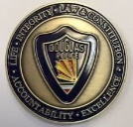
DOUGLAS POLICE DEPARTMENT
DAILY BULLETIN FOR JUNE 10, 2020

- An information report was taken in the area of 16th street and Bonita Avenue.
- A motor vehicle accident report was taken at the 1200 block of 11th street.

