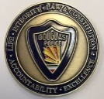
DOUGLAS POLICE DEPARTMENT
DAILY BULLETIN FOR JUNE 7, 2020

- A criminal damage report was taken at the 800 block of 3rd street.
- A VIN inspection report was taken on Highway 191.
- A fictitious plate report was taken at the Port of Entry.

